6 Day Luxury Yoga Retreat – Luxury yoga retreat nestled along the banks of the mighty Zambezi River. Enjoy yoga sessions while taking in the views of the river from our luxury tented camp, whilst relaxing and rejuvenating with the sounds of nature at your feet.
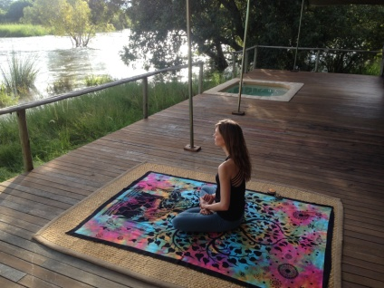
Day 1:

- Road transfer from VFA to the Zambezi Sands Hub (approximately 40 mins), where you will be picked up by a 4x4 vehicle to take you the remaining distance to Zambezi Sands River Camp (approx 45 mins).
- Settle in, unpack and take in the stunning view of the Zambezi River flowing right in front of your room.
- Sunset drinks to welcome you and to get to know your yoga instructors while the sun sets over the Zambezi River.
- Freshen up and indulge in a 3 course dinner in the elegant main lodge area.
DAY 2:

- As the sun rises an early morning Yoga session listening to the rapids of the Zambezi River followed by tea or coffee and a tasty breakfast on the main lodge deck.
- Tackle the mighty Zambezi River on our inflatable canoes and enjoy the sights of the river as you cruise down it.
- Stop off at one of our picturesque picnic spots for a delicious lunch and siesta before taking a slow drive back to the lodge in the afternoon.
- Once back in camp relax for an hour or two in your private splash pool watching the game and birdlife on the river’s edge.
- Enjoy an evening meditation session as the sun sets on the Zambezi River.
- Return to camp and freshen up where a wonderful 3 course dinner awaits you.
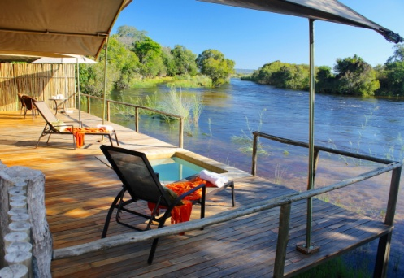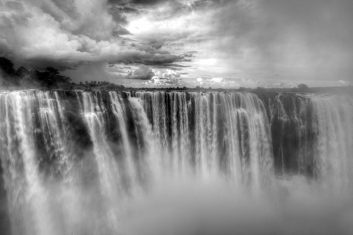

Day 3:

- Wake up at sunrise and experience a yoga session to get the day started.
- Freshen up and have a tasty breakfast while relaxing on the main lodge deck after your Yoga session.
- Take a guided walk into Zambezi National Park, escorted by a fully licensed and experienced guide who will share their knowledge and love of the bush with you. Getting close up to Africa's pristine wildlife will be an experience never to be forgotten.
- Return to the camp to relax and have lunch while putting your feet up.
- Treat yourself to a relaxing spa treatment or return to your private room and take a rest for the afternoon.
- Climb aboard our pontoon for a river cruise where you will experience a meditation session while floating down the Zambezi River listening to the water flowing through the rapids.
- Freshen up, sit down and enjoy a delicious three course meal in the main lodge dining area.

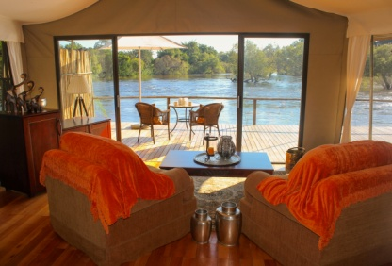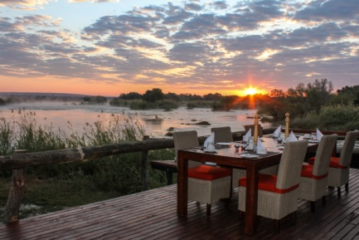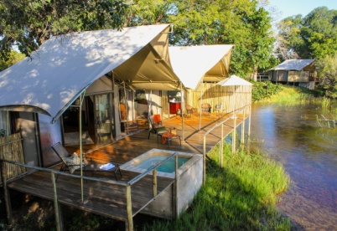

Day 4:
- Early morning Yoga class listening to the sounds of the wild animals and nature of the Zambezi National Park followed by a delicious breakfast.
- Morning transfer to town (1 hour) to go see the majestic Victoria Falls and take a walk through the rainforest.
- Take a visit to the curio shops and afterwards have some lunch in town.
- Return transfer to the camp where an evening meditation session awaits you.
- Freshen up and enjoy a three course dinner underneath the stars.

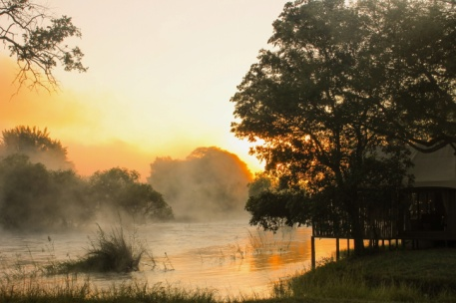

Day 5:
- Early morning Yoga class to begin your day.
- After breakfast enjoy a game drive into the Zambezi National Park with a qualified guide.
- A destination lunch awaits you on the banks of the Zambezi River; choose to treat yourself to a safari spa treatment whilst you relax at lunchtime.
- Return to the camp and take a rest before an early evening meditation session to relax and rejuvenate the mind.
- Freshen up and enjoy dinner with the sounds of the rapids in the background.

Day 6:

- As the sun rises an early morning Yoga session listening to the rapids of the Zambezi River followed by tea or coffee and a tasty breakfast on the main lodge deck.
- Take a game drive into the park for one last time, a memory that will last a lifetime.
- Transfer to VFA via the Hub (1 hour) to depart and say goodbye.

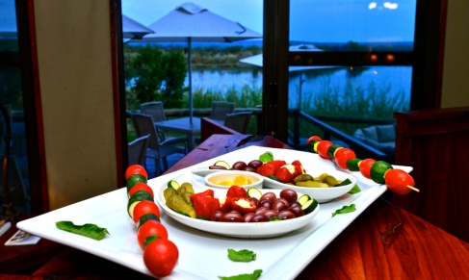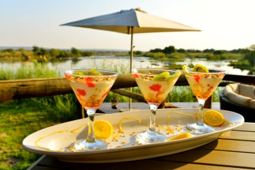
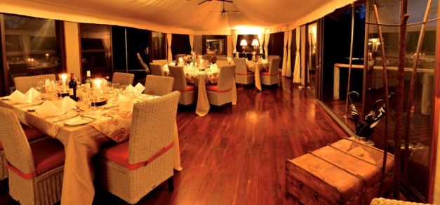

The Yoga Safari Experience
‘Unite body, mind & soul in the wilderness’

On a yoga safari not only will you feel the union of your body, mind & soul; you will also feel rejuvenated & revitalized.
Surrounded by bush birds and beasts as you practice daily asana and meditation classes which will stretch your body and mind to deepen the ultimate goal of yoga, to reach a state of pure African bliss.
Ground your feet in African soil and breath in the fresh air to find your ‘inner wild’ while you do yoga on safari

Vinyasa Yoga - commonly referred to as flow yoga. A type of yoga that links movement and breath to attain balance in the mind and body. From the Sanskrit ‘to place in a special way’, Vinyasa aligns a deliberate sequence of poses with the breath to achieve a continuous flow. Vinyasa classes offer a variety of postures and no two classes are ever alike.
Hatha Yoga – gentle, basic yoga classes with no flow between poses. Expect a slower paced stretching focused class with some basic Pranayama breathing exercises with relaxation and/or meditation at the beginning or end of each class. Hatha classes are good to work on your alignment, learn relaxation techniques and become comfortable with doing yoga while building strength and flexibility.
Restorative Yoga – Is the centering of your breath & body – aligning the physical and mental by practicing stillness and gentle movement for extended periods of time. It’s about slowing down and opening the body through passive stretching. If you take a restorative class, you may hardly move at all, doing a few postures in a course of an hour. During those long holds, your muscles relax deeply. It’s a completely different feeling from the other types of yoga classes since props are used to support your body as opposed to using your muscles.

Robyn Brookes – Yoga Instructor
Danielle Connolly - Yoga Instructor

PLEASE NOTE FOR ALL PACKAGES:
- Rates include national park entry fees
- Rates for packages that include air transfers are for a minimum of 2 people and these rates are subject to change without prior notice
- Some activities are provided through 3rd party suppliers and may be subject to change
- Please note the Elephant Express has to run according to scheduling specified by the National Railways of Zimbabwe and as such may be subject to delays and cancellations, which are beyond our control.
- This is a sample itinerary and may be adapted based on circumstances on the ground
- The Horse Riding Safaris and Spa Treatments are external activities from the lodge and are not inclusive of the package.
- The school visits are seasonal and according to the school calendar, if it is school holidays a village tour will be organized.

